**SETTING UP TELEGRAF ON REMOTE SERVER**

**(While working on windows, run all commands in PowerShell(Admin))**

__________________________________________________________________

1. Download telegraf from the following link:

[**https://portal.influxdata.com/downloads/**](https://portal.influxdata.com/downloads/)

1. Install telegraf in windows as a service outside the Virtual Box. (Run the commands in PowerShell(Run as Admin))

wget <https://dl.influxdata.com/telegraf/releases/telegraf-1.10.4_windows_amd64.zip>

unzip telegraf-1.10.4_windows_amd64.zip

If the the above commands don’t work in windows then use the following url in the url bar of your browser:

<https://dl.influxdata.com/telegraf/releases/telegraf-1.10.4_windows_amd64.zip>

This will automatically download the zip file and store it in your downloads folder.

1. Create the directory C:\Program Files\Telegraf (if you install in a different location simply specify the --config parameter with the desired location)
2. Place the telegraf.exe and the telegraf.conf config file into C:\Program Files\Telegraf
3. To install the service into the Windows Service Manager, run the following in PowerShell as an administrator (If necessary, you can wrap any spaces in the file paths in double quotes ""):  
   **> C:\"Program Files"\Telegraf\telegraf.exe --service install**
4. Edit the configuration file to meet your needs.
5. To check that it works, run:

**> C:\"Program Files"\Telegraf\telegraf.exe --config C:\"Program Files"\Telegraf\telegraf.conf --test**

1. To start collecting data, run:

**> net start telegraf**

In Powershell(run as admin)

1. Open the telegraf config file in windows and go to the “OUTPUT PLUGIN” section.

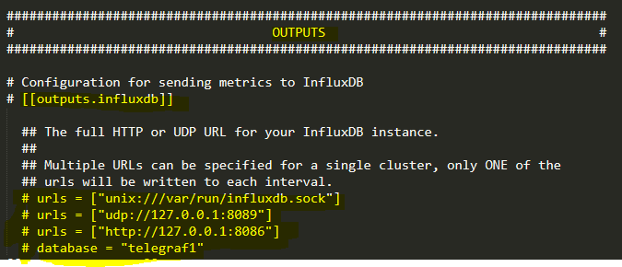

1. To define outputs to multiple servers:

[[outputs.influxdb]]

urls = ["http://server1:8086"]

# ... other options ...

[[outputs.influxdb]]

urls = ["http://server2:8086"]

# ... other options …

For Example:

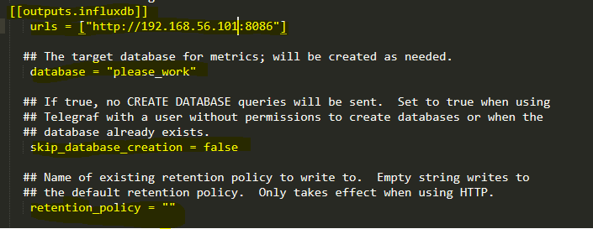

These settings will enable output to the server “192.168.56.101:8086”.

8086 is the port for influxdb.

The data from windows is sent via telegraf to influxdb in ubuntu with ip “192.168.56.101” and stored in a new database called “please_work”.